Graph is a Tree

Given an undirected graph, determine whether or not said graph is a tree.  
  
Input: Undirected Graph  
Output: Boolean

# Example

Input:

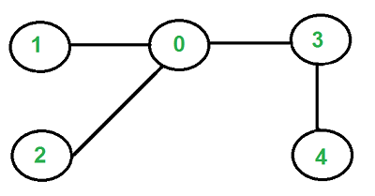

=> Output: True

Input:

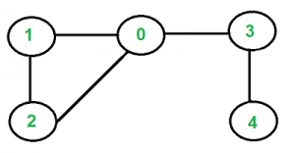

=> Output: False

# Constraints

Time Complexity: O(N)  
Auxiliary Space Complexity: O(N)  
  
The graph Vertex has the following properties:

value : an integer  
 edges : a list which contains references to other vertices in the Graph  
  
You may assume the values of the vertices will all be unique.

# Solution

An undirected graph is a tree if the following two conditions are met:

1. There is no cycle among the vertices
2. All of the vertices of the graph are connected

To detect a cycle:

1. Perform either DFS or BFS through the graph
2. For every vertex, check to see whether or not there is an adjacent vertex that we have already visited that is not the “parent” of the current vertex
   1. If this check returns true, then we know there is a cycle
3. If we search through the entire Graph and do not return false, then we know there is no cycle and can return true

To detect connectivity:

1. Perform either DFS or BFS through the graph starting at any vertex
2. Check to see whether all the vertices are reachable
3. If we can reach every vertex then we know the graph is connected and can return true, otherwise return false

# Resources

<http://quiz.geeksforgeeks.org/check-given-graph-tree/>